MM Case Study

Student Name: ­­­­­­­­­­­­­­­­­­­­­­­­­­_Addison Babcock_________________ User ID (GBI-###) GBI-036

Date: October 11, 2016

|  |  |
| --- | --- |
| **Description** | **Your Data** |
| Vendor Search Term (S/B your ###) (p3) | 036 |
| Tax Number 2 (p4) | 12-3456036 |
| Your Vendor number (p4) | 125004 |
| Purchase requisition number (p11) | 0010000013 |
| RFQ number for Mid-West (p15) | 6000000004 |
| RFQ number for Dallas Bike Basics (p15) | 6000000006 |
| RFQ number for Spy Gear (p15) | 6000000008 |
| Standard PO number (p22) | 4500000002 |
| Goods Receipt Material Document (p24) | 5000000011 |
| Invoice document no. (p27) | 5105600124 |
| Goods Receipt Material Document (p29) | 5000000011 |
| Invoice document no. (p30) | 5105600125 |
| Vendor Payment document (p32) | 1500000007 |

Insert an image of Header note from page 10. (Use Snipit tool). The image should only be of the data i.e., not a full screen shot (similar to the sample below). The content of the text message should be similar as well but with your GBI-### number.

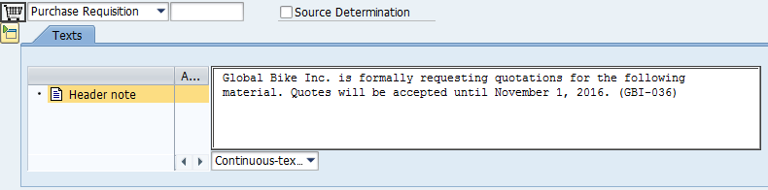

From p30 Item details (see sample below).

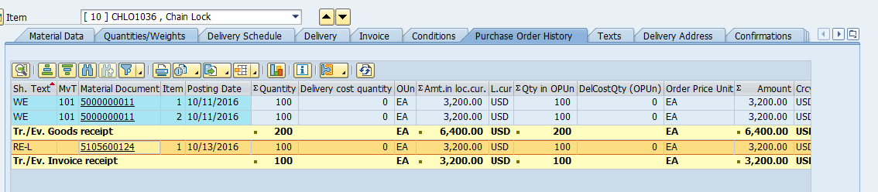

From p36 capture your document number and *Gen. Ledger Line Items: Display* and circle *User Name*.

See sample below.

